Diamond Price Analysis and Prediction
Name: Gauri Ghode
Roll Number: SA207
Project Title: Diamond Price Analysis and Prediction
Problem Statement: This project analyzes the diamonds dataset to study which features affect diamond price and to build a simple prediction model. The original dataset has 53,940 rows and 10 columns, and duplicate rows were removed before analysis.
Dataset Description: Diamonds dataset from the plotnine package. Original rows: 53,940. Rows after duplicate removal: 53794. Columns: 10. Main columns are carat, cut, color, clarity, depth, table, price, x, y, and z.
GitHub Link:

Import Libraries - Code Screenshot
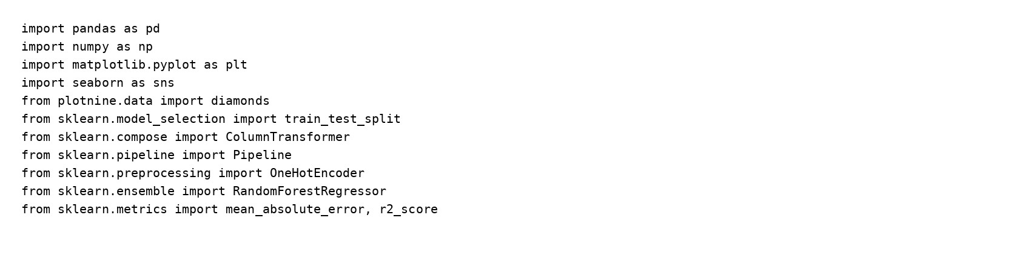
All required libraries are imported in one cell.

Load Dataset - Output Screenshot
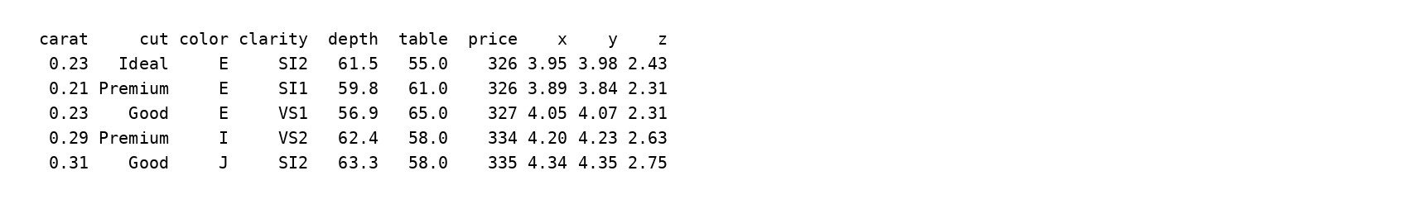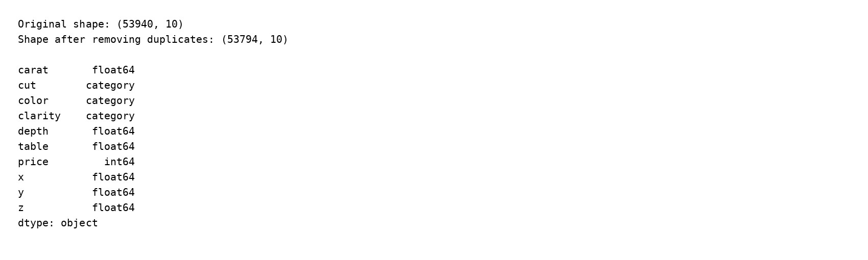
The dataset loads correctly and includes both numeric and categorical columns.

Data Cleaning - Output Screenshot
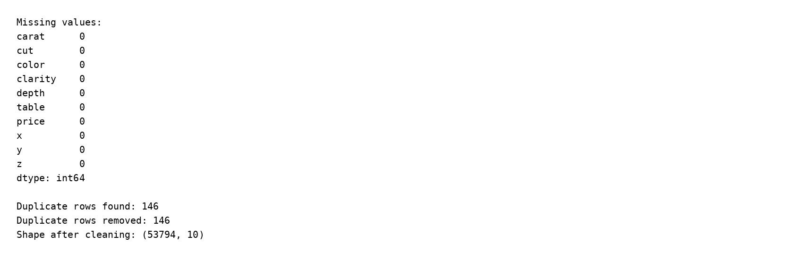
No missing values were found. The dataset had 146 duplicate rows, and those rows were removed before analysis.

Descriptive Statistics - Output Screenshot
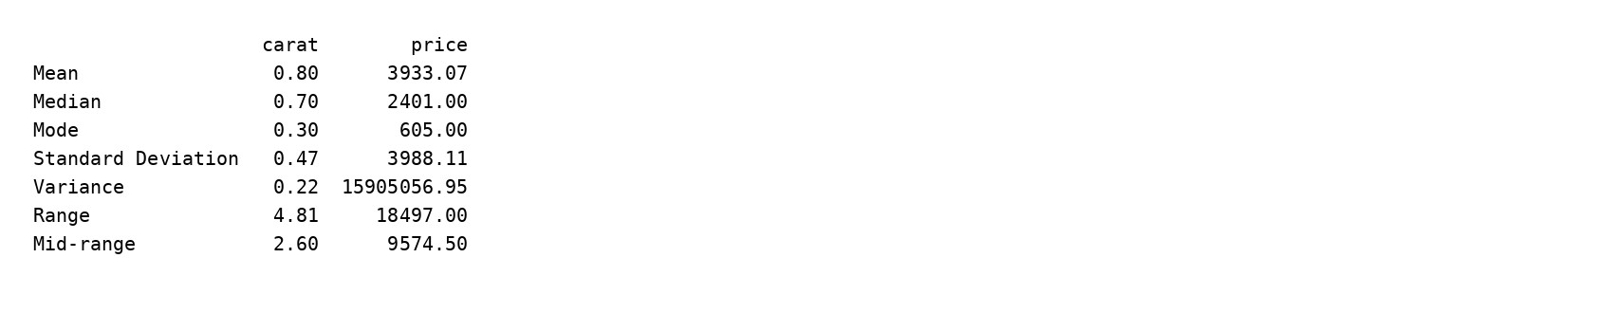
This table shows mean, median, mode, standard deviation, variance, range, and mid-range for carat and price after cleaning.

Visualization 1: Histogram
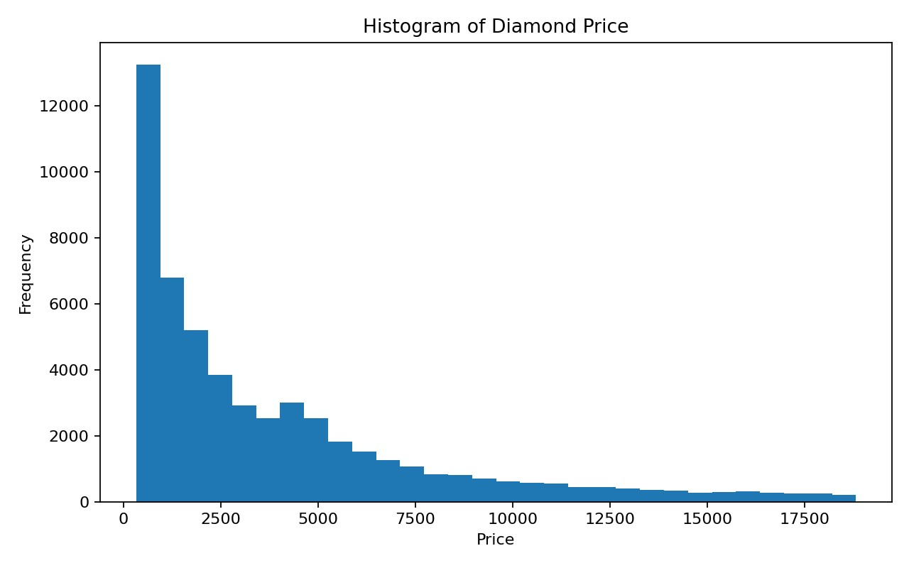
Interpretation: Most diamonds are in the lower price range, while only a small number have very high prices.

Visualization 2: Bar Chart
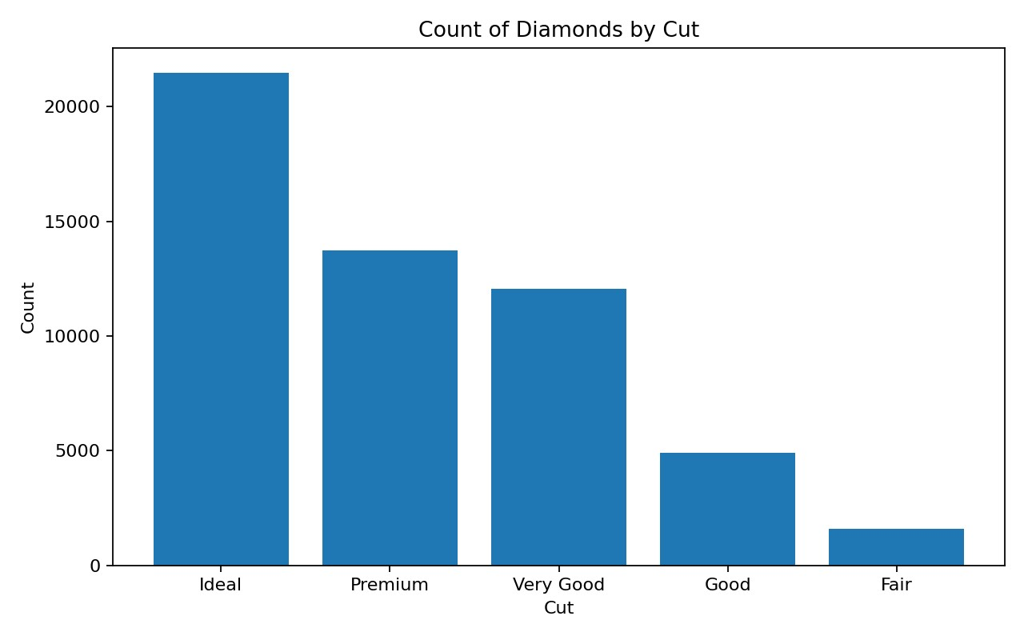
Interpretation: Ideal cut diamonds are most common in the cleaned dataset, while Fair cut diamonds are least common.

Visualization 3: Boxplot
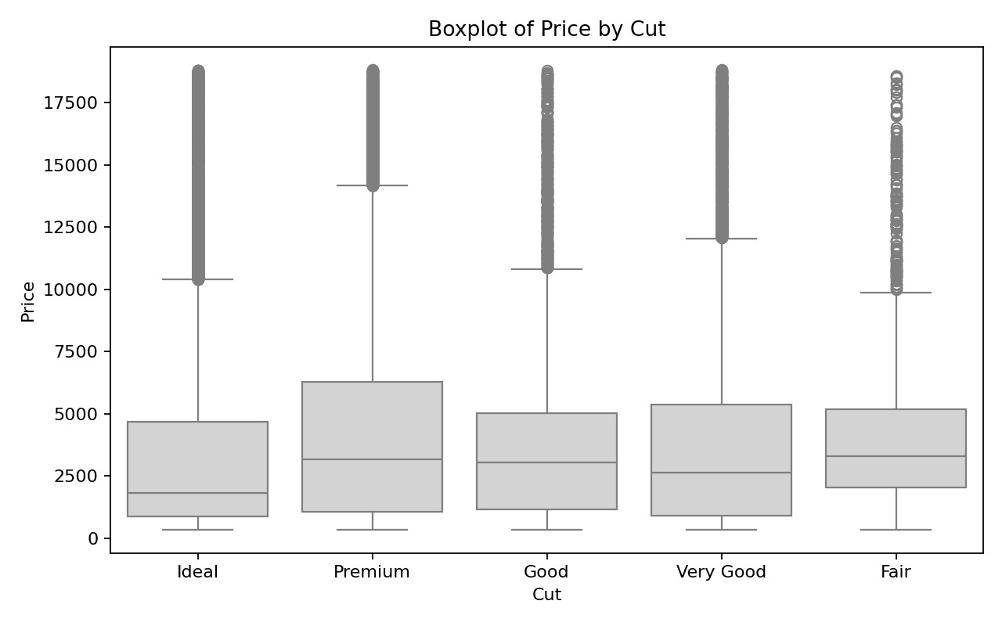
Interpretation: Diamond price shows a wide spread across cut categories, with many high-price outliers.

Visualization 4: Correlation Heatmap
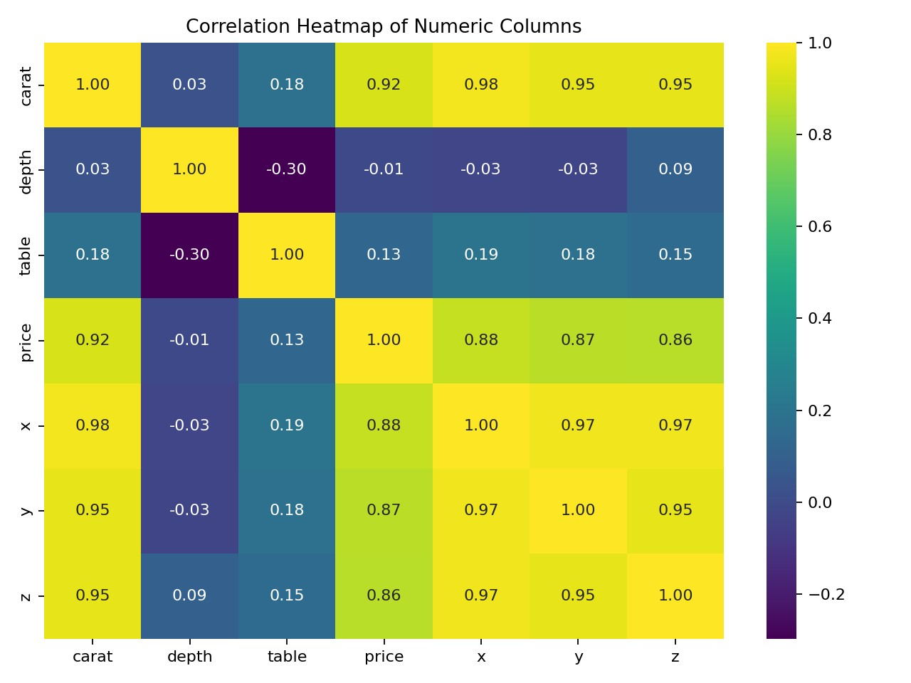
Interpretation: Carat has the strongest positive correlation with price among the numeric variables.

Model Result - Output Screenshot
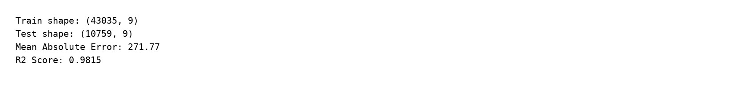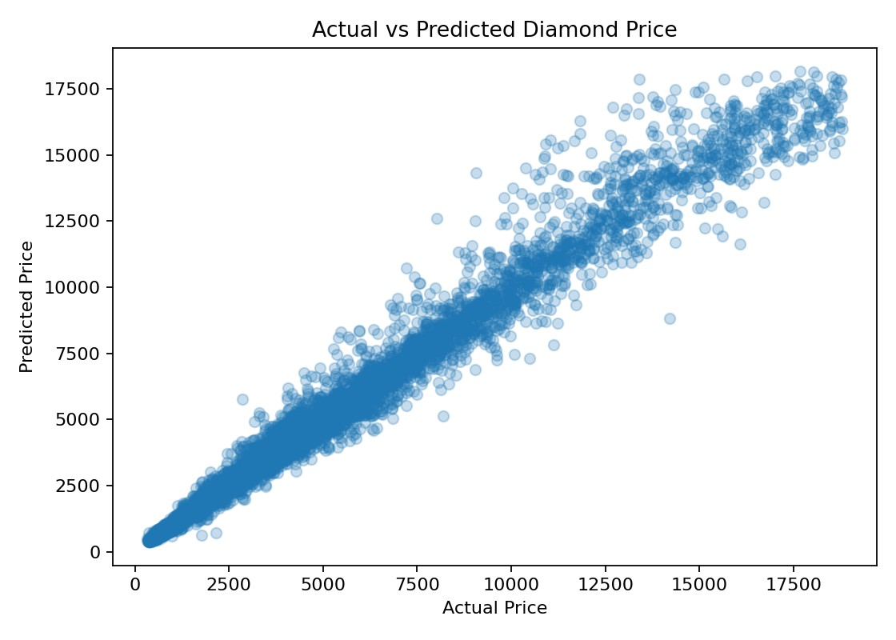
Model explanation: After encoding categorical columns and splitting the cleaned data into 80% training and 20% testing sets, the model achieved a Mean Absolute Error of 271.77 and an R² Score of 0.9815. This means the model predicts price quite accurately overall.

Final Insights and Recommendations
Finding 1: The histogram shows a right-skewed price distribution, so lower-priced diamonds are more common than high-priced ones.
Finding 2: The bar chart shows that Ideal cut is the most frequent category in the cleaned dataset.
Finding 3: The boxplot shows many outliers, meaning some diamonds are priced much higher than the rest.
Finding 4: The heatmap shows that carat has the strongest relationship with price.
Finding 5: The model result (R² = 0.9815) shows that the selected features are strong predictors of price.
Recommendation 1: Sellers should focus strongly on carat and size because they influence price a lot.
Recommendation 2: Jewelry businesses can use a simple prediction model to estimate prices quickly and support decision-making.

